**Project-Report**

**Tic tac toe**



**Submitted to: Miss Rafia Shaikh**

**By:**

**(Fa21-bsse-0051 Basit**

**x**

**Fa21-bsse-0056 Alqama)**

**Date: 3-Jun-2022**

**Department of Computer Science**

##### Muhammad Ali Jinnah University

22-E Block 6, PECHS, Karachi-Pakistan

**1. Introduction:**

It is a very basic game that every body knows how to play !

**2. Problem Statement:**

Everybody gets bored in free time they need entertainment in that time so we decided to make a game that can solve their problem.

**4. Project Description:**

* **Libraries/Procedure/technics:**

it’s very easy game that I mentioned early in Introduction that every person played this game once in his life. We have 2 players in this game only one can win this game. We have 9 boxes in this game we have to make 1 straight line in 3 boxes but no matter where line are align its need to be 3 boxes parallel or perpendicular.

**(output snappits)**

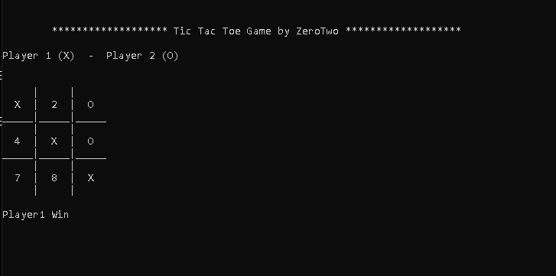

**5. Conclusion:**

no one will get bored in their free time…!!!